PROBABILITY TREES
Pearson Edexcel - Tuesday 6 November 2018 - Paper 1 (Non-Calculator) Foundation Tier

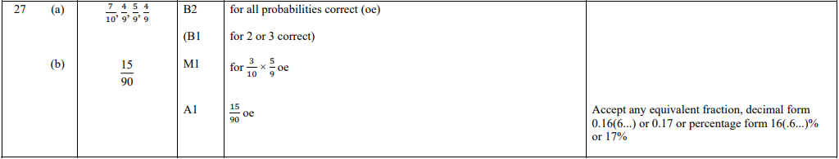

Pearson Edexcel - Tuesday 12 June 2018 - Paper 3 (Calculator) Foundation Tier

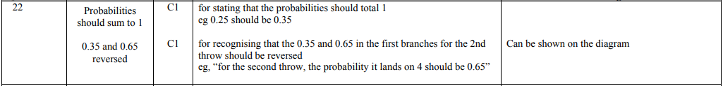
OCR Thursday 05 November 2020- Morning (Non-Calculator) Foundation Tier
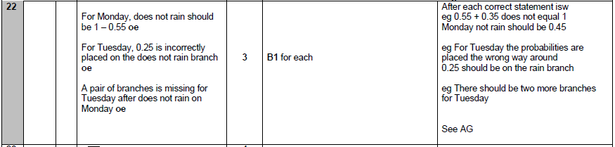

OCR November 09 November 2020- Morning (Calculator) Foundation Tier
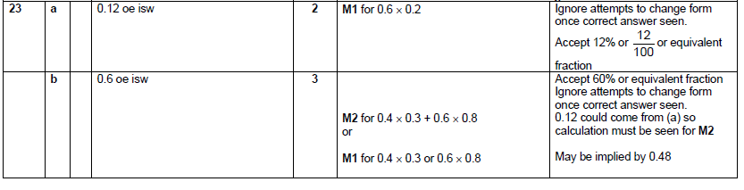

OCR Tuesday 5 November 2019 – Morning (Calculator) Foundation Tier
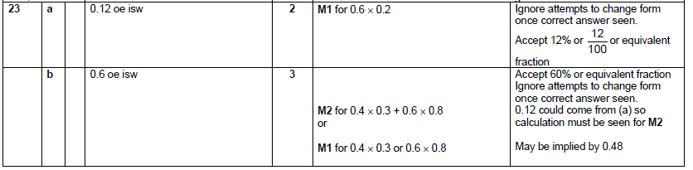

OCR Monday 11 November 2019 – Afternoon (Calculator) Foundation Tier
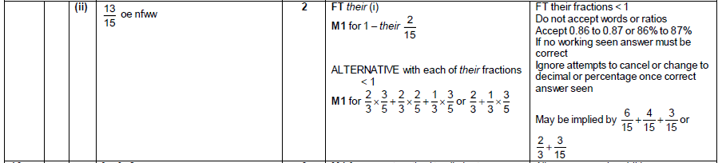
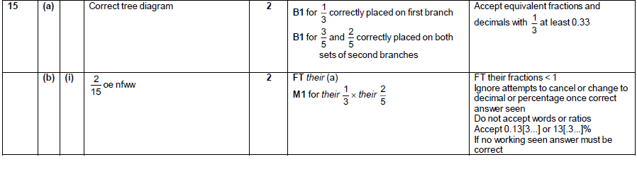

OCR Thursday 6 June 2019 – Morning (Non-Calculator) Foundation Tier
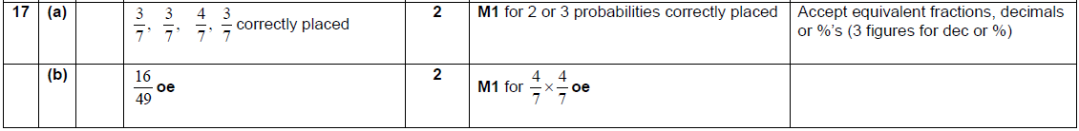

OCR Tuesday 6 November 2018 – Morning (Calculator) Foundation Tier
OCR Monday 6 November 2017– Morning (Calculator) Foundation Tier
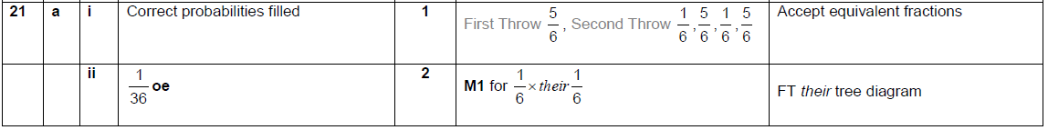

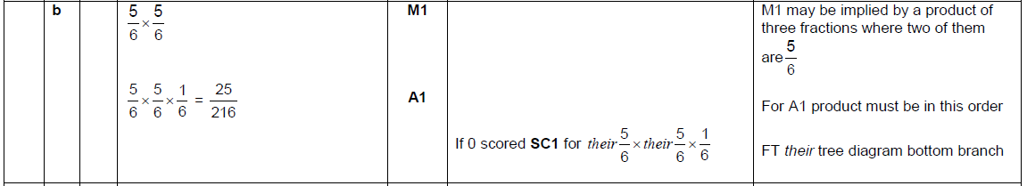

Pearson Edexcel –Sample Papers - Paper 2 (Calculator) Foundation Tier

OCR Thursday 25 May 2017 – Morning (Calculator) Foundation Tier

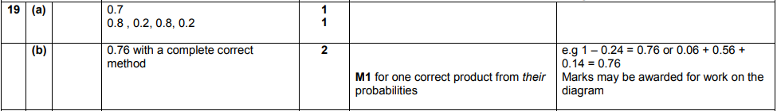

AQA Tuesday 21 May 2019 – Morning (Non-Calculator) Foundation Tier

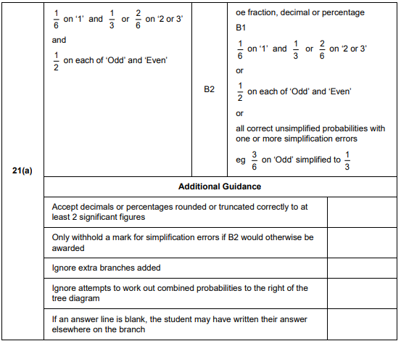
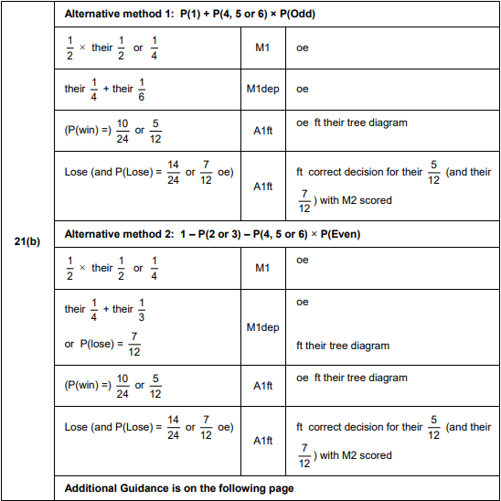
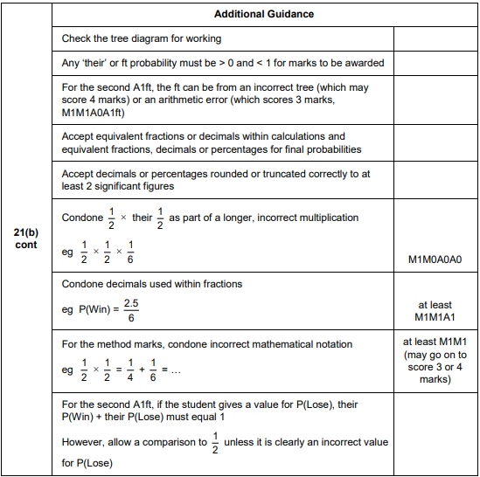
AQA Thursday 7 June 2018 – Morning (Calculator) Foundation Tier

